Hair Analysis Microscope Lab

Name: Date: Period:
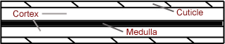
Background Information:
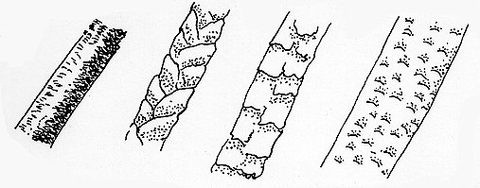
Identifying whether the hair is human or animal is the first step in forensic hair analysis. Human hairs usually have a thin (less than ⅓ of the hair’s diameter) or an absent medulla region. Animal hairs usually have thick medulla (more than ½ of the hair’s diameter). Look at the photos below for examples of what you might see with the microscope.

Human Cat Dog Mouse

Lab Materials
- Microscope Slide Water Strands of Hair
- Coverslip Microscope Pipette
- Paper to set-up as lab sheet Pencil (to draw/write with)

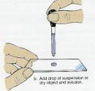
Lab Procedure:
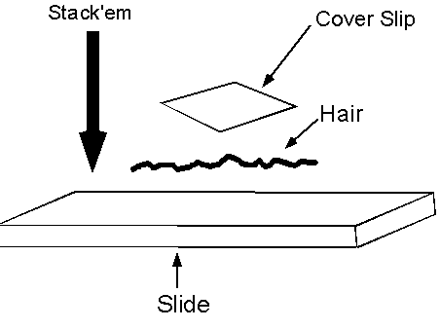
- Obtain a clean microscope slide and place a drop of water on it.
- Place several strands of hair on the drop of water.
- Slowly lower a coverslip onto the drop of water/hair.
- Examine the slide under the low- medium- and high-power objectives of a microscope.
- Draw the hair while noting any internal features such as medulla, cortex, cuticle, granules or air spaces.
- Label the features you just drew.
- Repeat Process for the different types of hair

