Answer Key: Earthquakes – Background Knowledge on Fault Motion

Name(s) All names in your group Date: 10/29/12 - 30th Period:
Expectations/Criteria
Exemplary + | Proficient ☑ | In-Progress (IP)
Proficient +  - Scientific terms (see “Other Vocabulary” below) used to accurately answer 90% + | - Records answers for all 4 types of faults  - Answers all 15 questions with 80%+  - Answers are in own words | Meets fewer than 3 of proficient criteria

Assignment:
Please go to the Earthquake page on msbrownclass.weebly.com
Under “Lessons” select “Fault Motion”
If using Google Drive, make a copy of this form, and then share it with your partner so both of you can access the form.

Directions:
Partner work- watch, read and discuss together
For each of the different fault motions:
- Start/watch the animation
- Read the supporting descriptions
- Discuss the questions and record the answer that you agree on
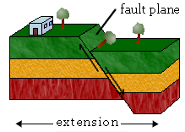
Dip-Slip Faults
A. Normal Fault
- If you saw this type of fault happen, what would it look like, how would you describe it? In a normal fault, which is a type of Dip-Slip Fault, the “block” of Earth... above the fault moves down compared to the “block” of Earth below the fault. If I were walking across the Earth when I came to the part that had slipped, it would look a big step down, or maybe like a cliff, depending on how much it had “dipped and slipped.”

- What causes this type of fault? A normal fault is caused by... tension forces, which can be a stretching and pulling of the Earth’s crust, and thins the rock in the middle.

- What does the word “extension” mean as applies to this fault? For faults, the term extension means... that the Earth is actually being stretched, it pulls the Earth apart and thins it where it is being pulled.

- What are other names for this type of fault? Other names for a “normal” fault are... normal-slip fault, tensional fault or gravity fault.
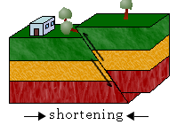
B. Reverse Fault
- If you saw this type of fault happen, what would it look like, how would you describe it? A reverse fault is a type of Dip-Slip Fault, and . . . the “block” of Earth above the fault moves UP. If I were walking it would look like a big chunk of Earth rose out of the Earth and made a hill or a wall of rock in front of me.

- What causes this type of fault? A reverse fault is caused by . . . compression forces which push the crust of the Earth together.

- What does the word “shortening” mean as applies to this fault? For faults, the term shortening means . . . that the crust of the Earth is being pushed together and it is getting shorter and thicker.

- What are other names for this type of fault? A reverse fault is also known as... a thrust fault, reverse-slip fault or compressional fault.

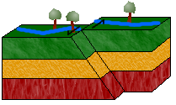
Strike-Slip Fault
- If you saw this type of fault happen, what would it look like, how would you describe it? In a strike-slip fault, the block of Earth on the far side moves sideways rather than up or down. If I was walking along a road where this had happened it would look the road swung out to the slide, like an “S.”

- What causes this type of fault? Strike-Slip Faults are caused by shearing forces. Shearing forces happen when a number of forces act on the crust from different sides.

- What does the words “left lateral” and “right lateral” apply to a Strike-Slip Fault? A lateral move means that the Earth is moving to the side, to the right or to the left. If the block moves to the left it’s a “left lateral,” if it moves to the right it’s a “right lateral.”

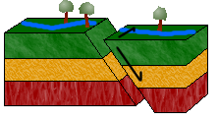
- What are other names for this type of fault? transcurrent fault, lateral fault, tear fault or wrench fault.

Oblique-Slip Fault
- If you saw this type of fault happen, what would it look like, how would you describe it? The Earth’s crust is moving in multiple directions. So it’s either moving up and down, or right or left; in other words, it is doing a “shearing” and a “lateral” motion.

- What causes this type of fault? Both shearing and compressing are happening in an Oblique-Slip Fault.

Other Vocabulary . . .
Review these terms and properly use them in your descriptions above to move towards “Exemplary.”
Strike: the horizontal line along the direction of a fault plane.
Dip: the angle between the fault plane and the horizontal.
Hanging wall: the block of Earth crust above the fault plane
Foot wall: the block of Earth crust below the fault plane.
Graben: the valley that is formed as one block drops down.
Horst: the hill that forms as one block moves up.

